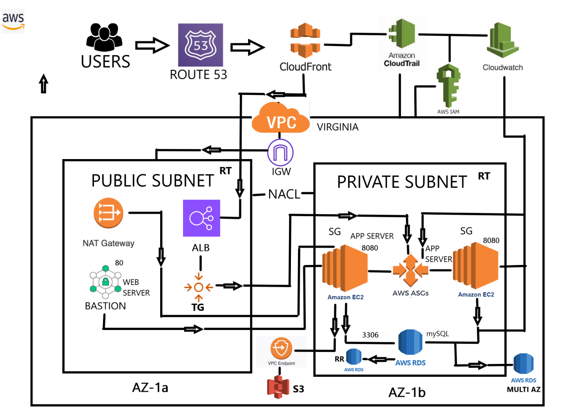

1. High Availability - Auto Scaling, ELB (Elastic Load Balancer, RDS Multi-AZ.

2. Performance Excellence: CloudFront, RDS Read Replicas, Auto Scaling.

3. Strong Security: IAM (Identity and Access Management), VPC (Virtual Private Cloud).

4. Cost Optimized: Reserved Instances, Auto Scaling, Cost Explorer.

